# **Energy Analytics**

Project Members

Muhammad Laraib uz zafar 14960

Abdul Moiz Siraj 14818

Hive Table generation using Hue

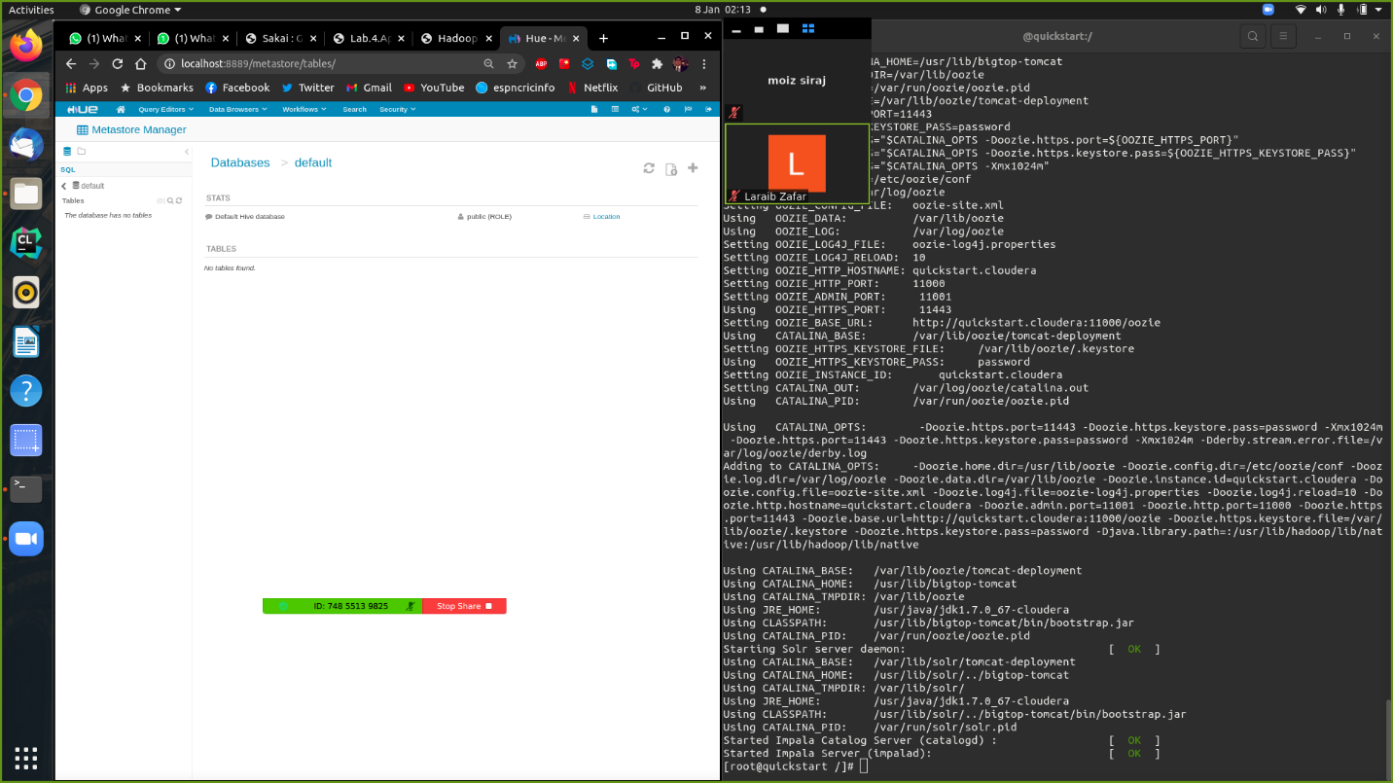 using the + sign we can make a new database

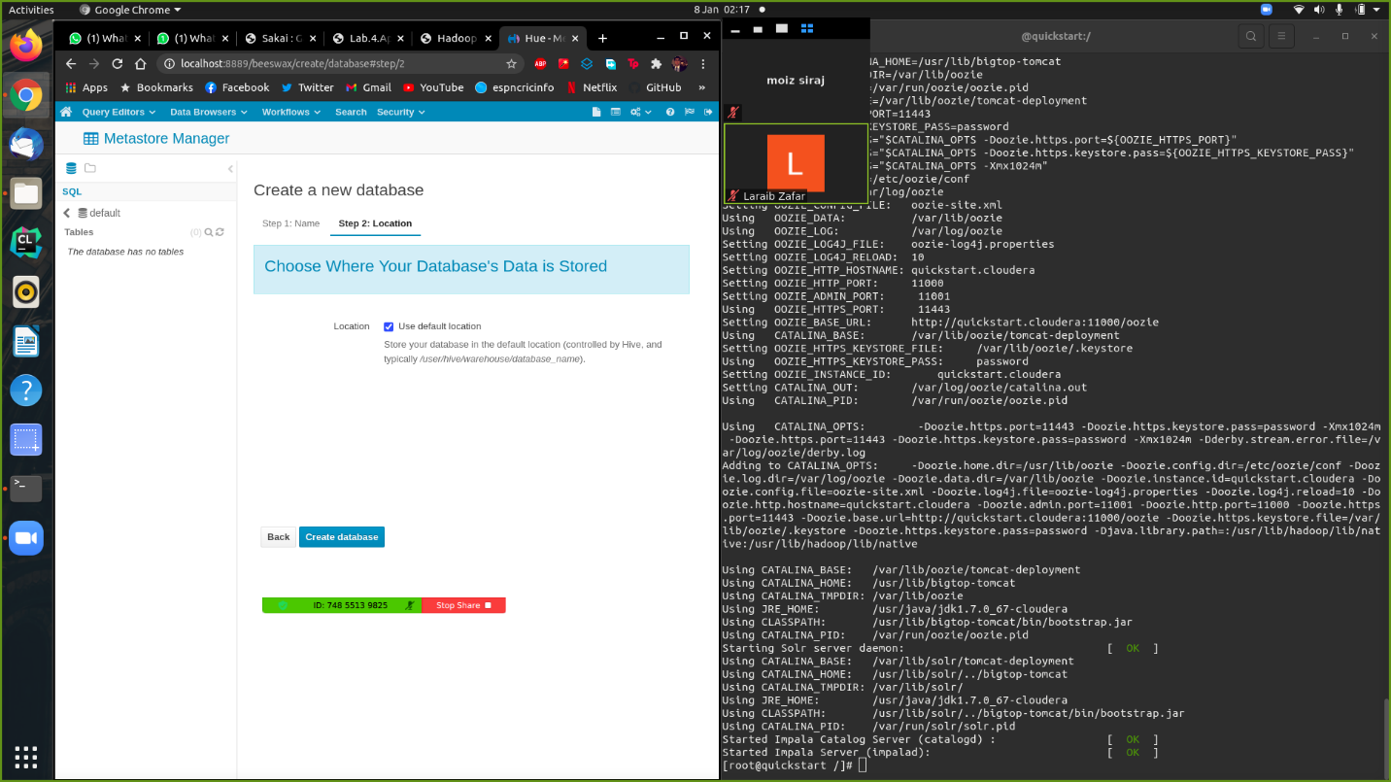

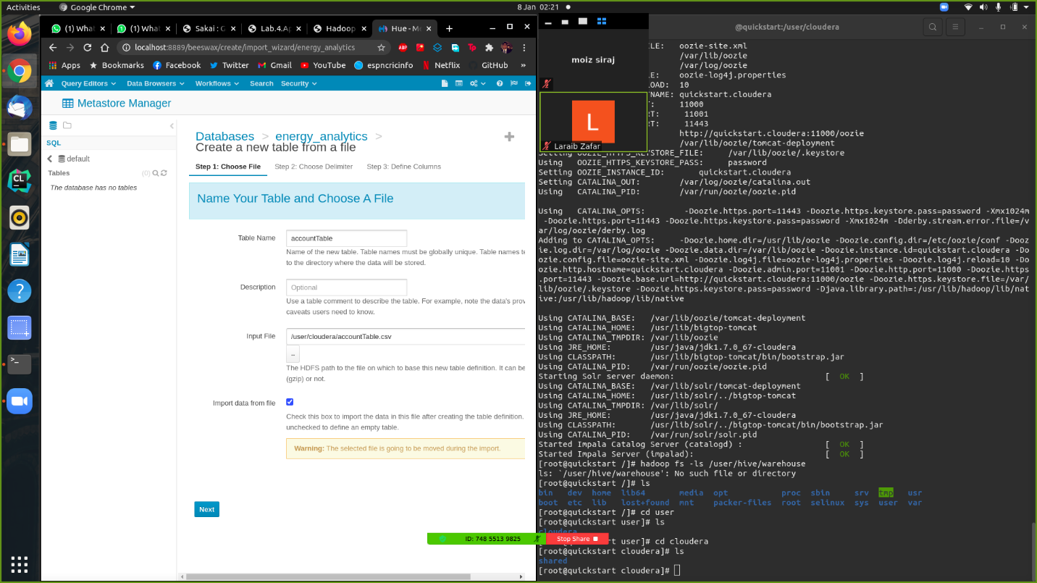In that database we can upload the CSVs we generated.

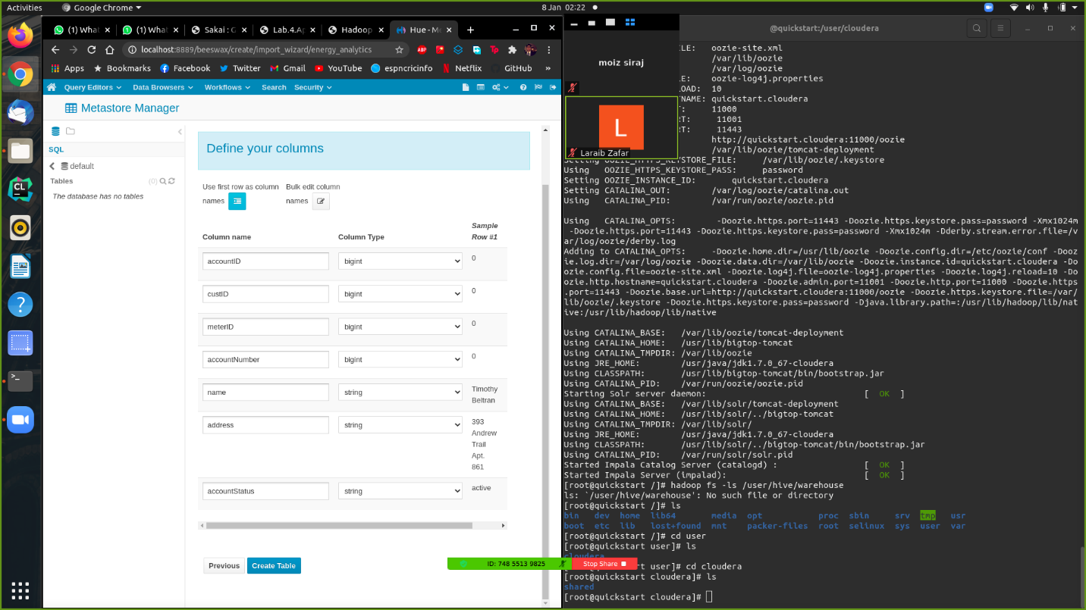You can view and edit the column types HIVE assigns to the tables you’ve uploaded.

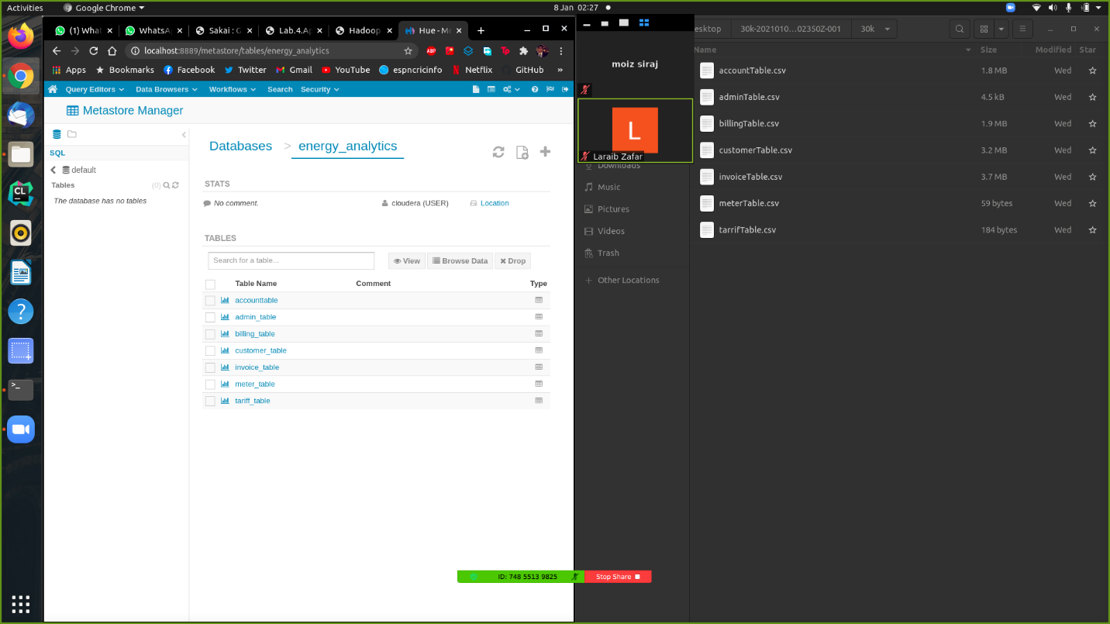Once you’ve uploaded all the tables to your database you can selectively view your dataset.

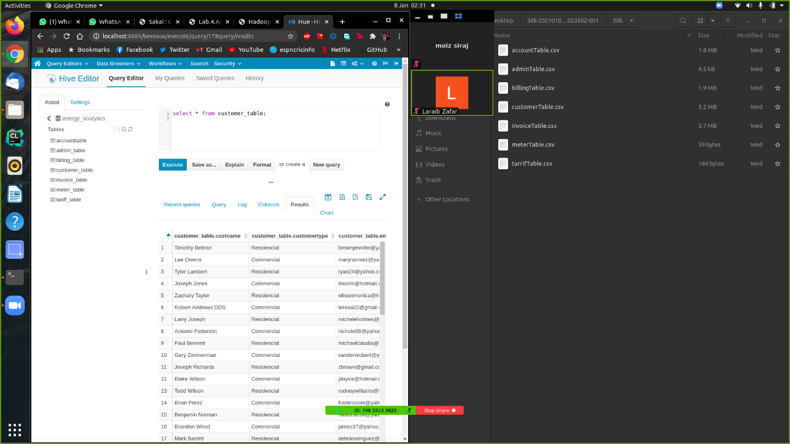You can write queries in the Query Editor, we’ve displayed a very basic query.

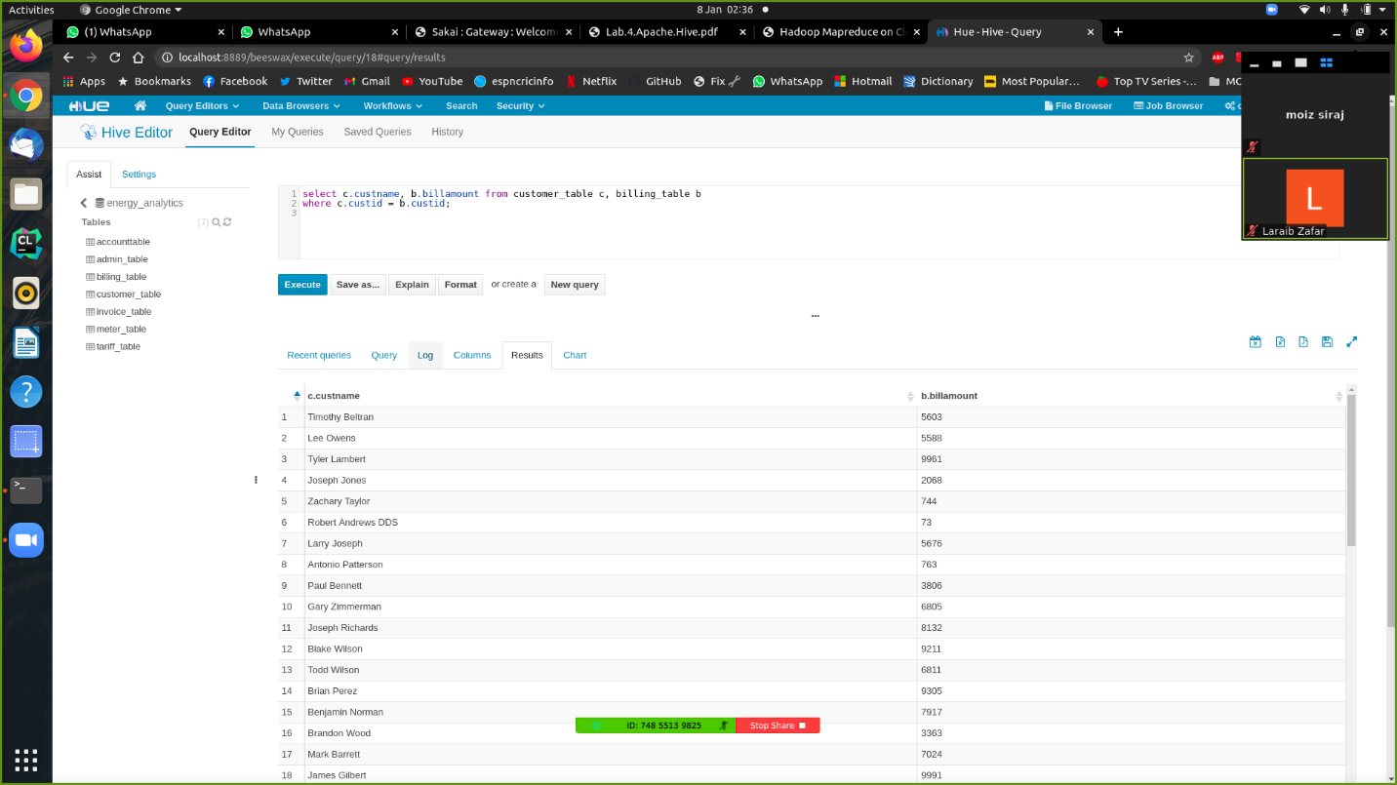We’ve demonstrated Joins using this query, now we’ll move onto more complex analysis of our dataset.

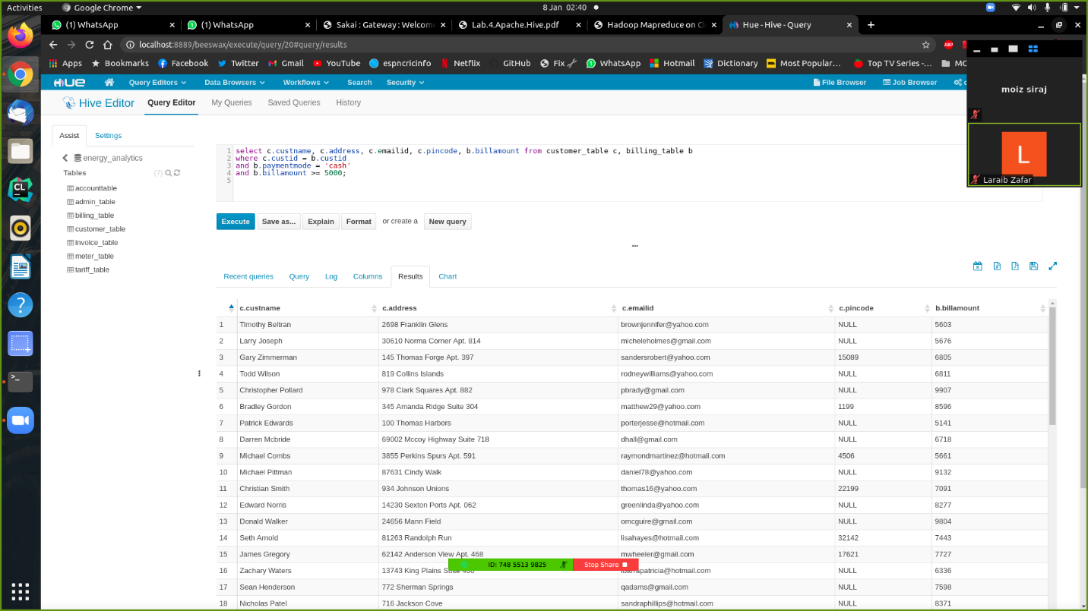

Print customer details where the customer incurred a bill of over 5000 RS

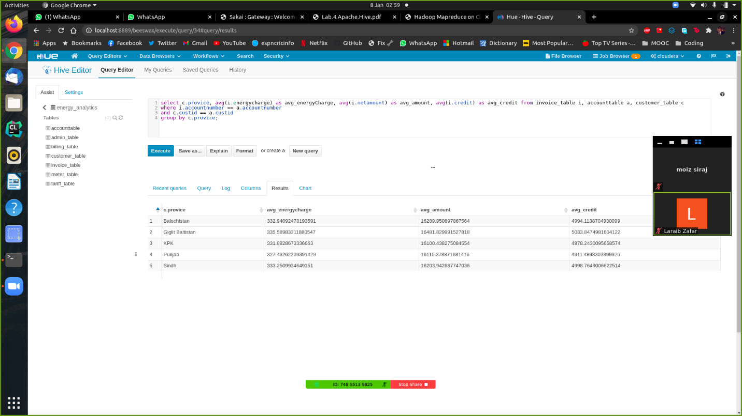Print Average energy consumption and billing details amongst all provinces, allows us to conduct a higher-level analysis on the province level

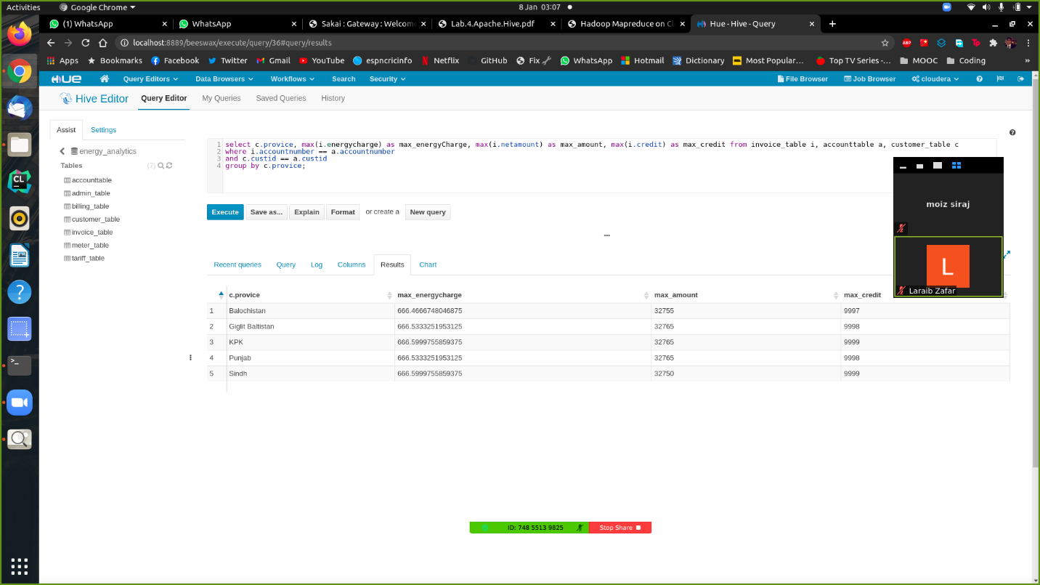

Print Max energy consumption and billing details for each province in Pakistan.

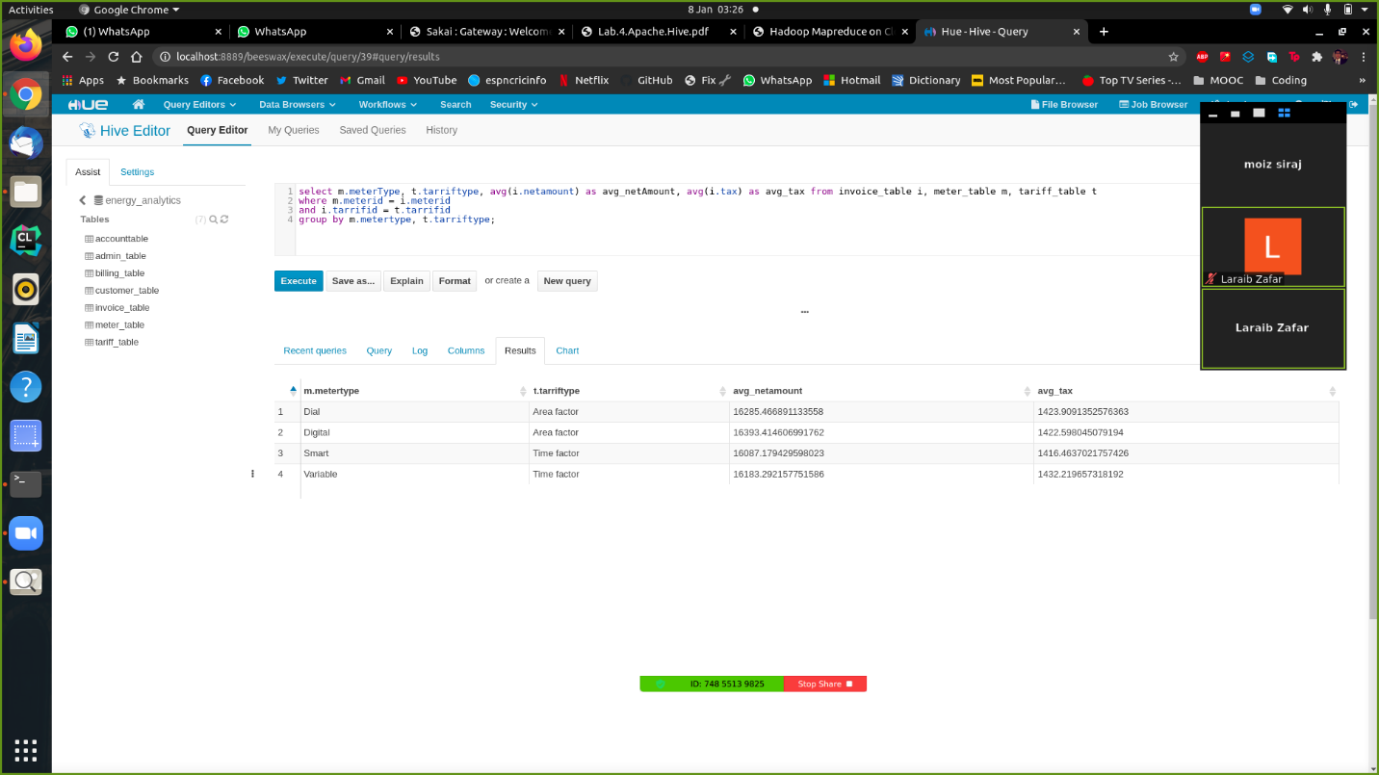

Print the average coverage charges and along with their tariff types for each type of meter.

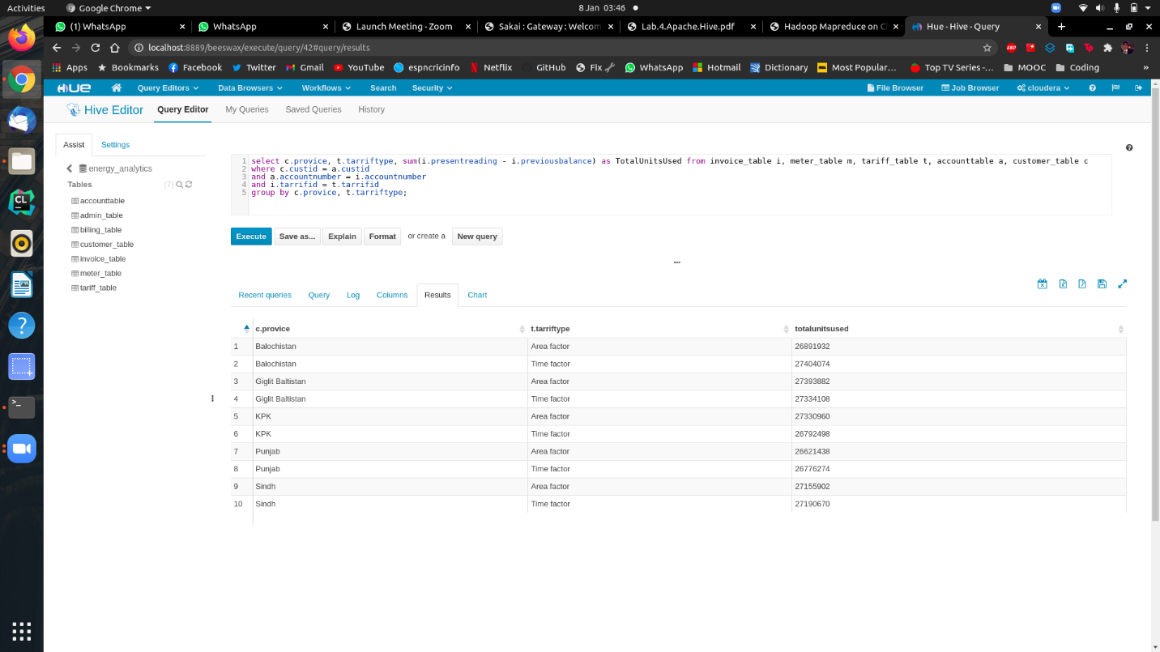

Total units used in each province along with the type of peak factor attached to it.

Trying to migrating data to Hive using the terminal

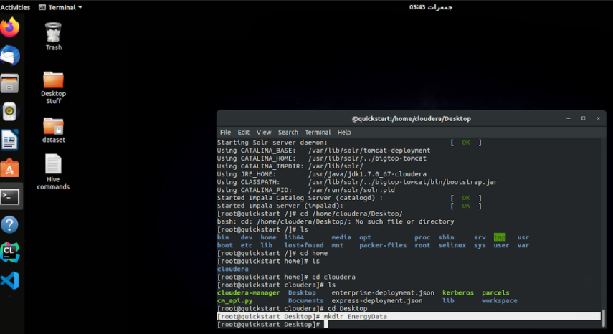

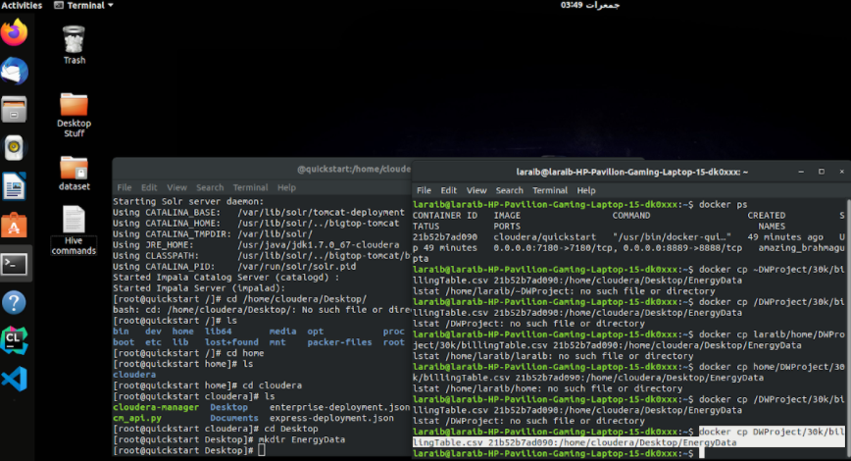

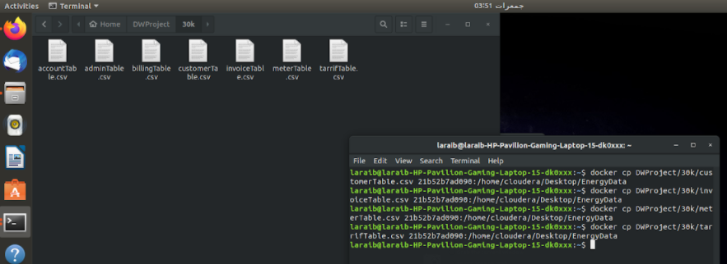

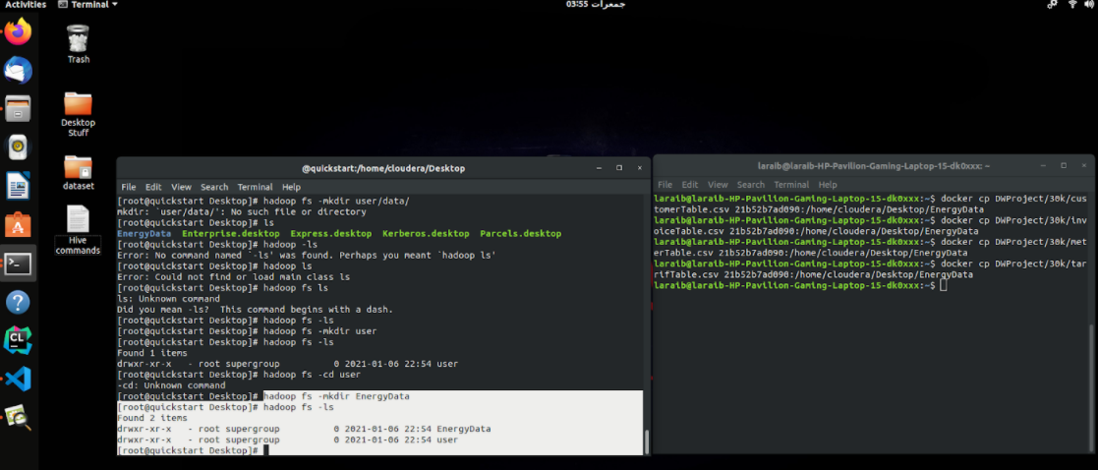

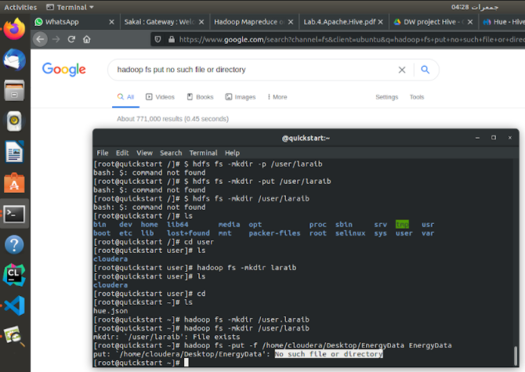

We couldn’t get past through this error, so we continued to do it using Hive.